**QUESTION 1**

1. In the screenshot below for sending parameters in Postman, what is “?id=1”?

You can refer to this <https://learning.postman.com/docs/sending-requests/requests/>

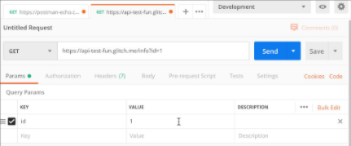

|  |  |  |
| --- | --- | --- |
|  |  | Request parameter - another term for query parameter |
|  |  | Query parameter - used for sorting/filtering resources |
|  |  | URL parameter - can be path parameter or query parameter |
|  |  | Path parameter - used for identifying specific resource/resources |

**1 points**

**QUESTION 2**

1. In sending body data in a post request with Postman, which of the following is NOT correct?

You can refer to this <https://learning.postman.com/docs/sending-requests/requests/>

|  |  |  |
| --- | --- | --- |
|  |  | You need body data when sending a request for adding or updating structured data |
|  |  | You can send various different types body data |
|  |  | You need to send body data for GET, PUT, POST, and PATCH |
|  |  | Content-Type (such as text/html and multipart/form-data) header is automatically attached by Postman |

**1 points**